Immature mosquito stage models for MASH

1. MASH EL4P model:

Model equations (full ODE form):

The EL4P model in ODE form should look something like this:

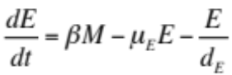 , (1)
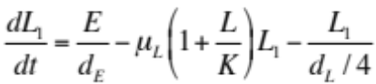 , (2)
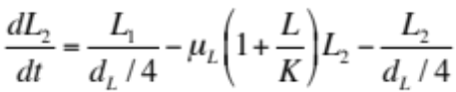 , (3)
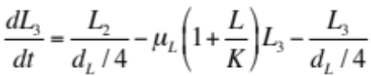 , (4)
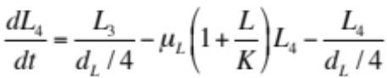 , (5)
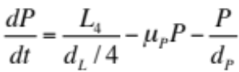 , (6)
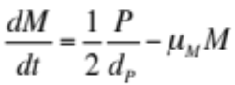 . (7)

Here, E represents the number of number of eggs, L represents the number of larvae, and L₁ through L₄ represent the number of stage 1 through 4 larval instars, P represents the number of pupae, and M represents the number of adult female mosquitoes at time t. The death rates of each of these life stages are denoted by μ_{E}, μ_{L}, μ_{P} and μ_{M}, respectively, and the durations of each of the immature life stages are denoted by d_{E}, d_{L} and d_{P}, respectively. The four larval instar stages are assumed to each have a duration equal to a quarter that of the full larval stage. The rate at which female mosquitoes oviposit eggs is denoted by β, and K represents the carrying capacity of the environment for larvae. Here, we have kept track of both male and female immature stages; however, at the adult stage, we are just keeping track of females, and hence adult female emergence is represented by half of the developing pupae.

Here and throughout, L = L₁ + L₂ + L₃ + L₄.

We can tailor the value of K to achieve a desired mosquito emergence rate, λ. The adult female mosquito emergence rate at equilibrium is:

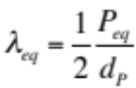 . (8)

Rearranging this equation for P_{eq}, we have:

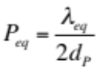 . (9)

Setting Equation 7 equal to zero, the adult female mosquito population size at equilibrium is:

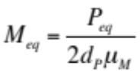 . (10)

Setting Equation 1 equal to zero, the egg population size at equilibrium is:

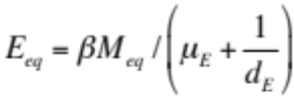 . (11)

Setting Equation 6 equal to zero, the fourth larval instar population size at equilibrium is:

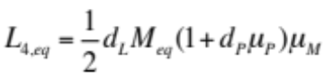 . (12)

Setting Equations 2-5 equal to zero, the first, second and third larval instar population sizes at equilibrium are:

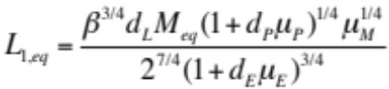 . (13)
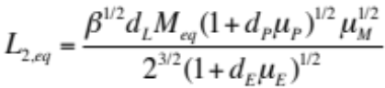 . (14)
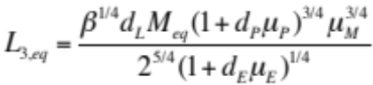 . (15)

We can then determine the value of K by setting Equation 2 to zero, which gives:

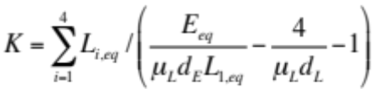 . (16)

Model equations (simpler ODE form):

For comparison, let’s also consider a simpler model in which all the larval stages are grouped into one, i.e.:

, (17)
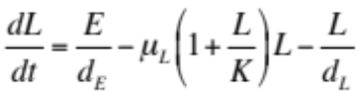 , (18)
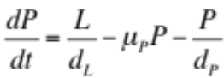 , (19)
. (20)

Again, we can tailor the value of K to achieve a desired mosquito emergence rate, λ. The adult female mosquito emergence rate at equilibrium and the egg, pupal and adult female population sizes at equilibrium are again given by Equations 8-11. Setting Equation 19 equal to zero, the larval population size at equilibrium is:

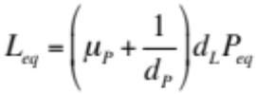 . (21)

Therefore, we can determine the value of K by setting Equation 18 to zero, which gives:

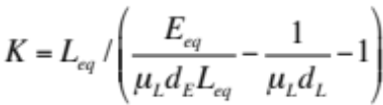 . (22)

Model equations (simpler difference equation form):

If the time step is small, then the following direct translation of the differential equations should be appropriate:

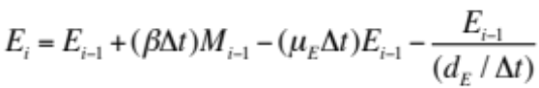 , (23)
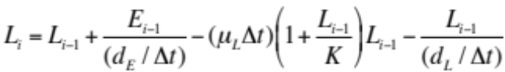 , (24)
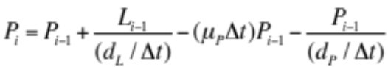 , (25)
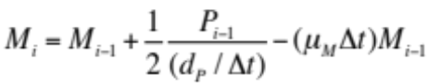 , (26)
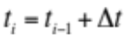 . (27)

Here, 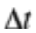 represents the time step, i represents the iteration number, and t_{i} represents the time at iteration number i. For very small time steps, the same equilibria hold for these equations as for the ODE formulation of the model; however, if the time step approaches the length of any of the event durations, then we run into problems.

Building upon this model, we convert rates into risks (risk = 1 – e^{-rate}), also taking into account that, in order to develop into the next life stage, it is first necessary to survive the current life stage. The resulting difference equations may be written as:

, (28)
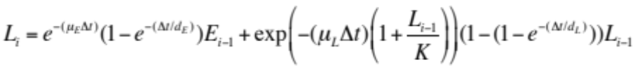 , (29)
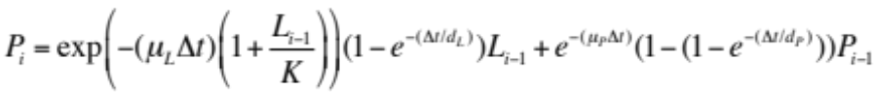 , (30)
. (31)
. (32)

This set of equations should display approximately the same equilibria as the ODE framework. We should do some coding to make sure that this is the case. In the difference equation framework, adult female mosquito emergence at time step i is equal to:

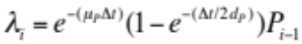 . (33)

Model equations (full difference equation form):

The version of the difference equations with four larval stages is given by:

, (34)
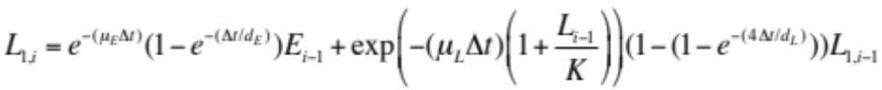 , (35)
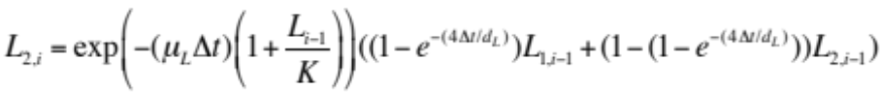 , (36)
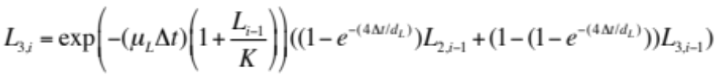 , (37)
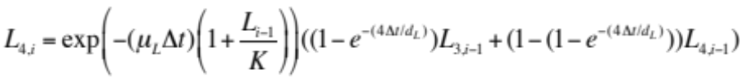 , (38)
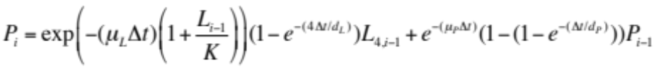 , (39)
, (40)
, (41)
. (42)

For a desired adult female emergence rate, the value of K can be chosen according to Equation 16, and initial equilibrium values for each of the life stages may be chosen according to Equations 9-15.

For a stochastic realization of this model, eggs laid may follow a Poisson distribution, and survival and development may follow a Bernoulli distribution at the individual level, and hence a Binomial distribution at the population level.

